**Report for Assignment 2 – Part I: Segmentation by Deformable Models**

**Ravikiran Janardhana**

**Medical Image Analysis – COMP 775**

**Fall 2011**

**Tasks completed**

* Read Yushkevich et al. SNAP Paper published in Neuroimage.
* Implemented a Matlab program to generate dark ellipse slices on a light background.
* Ran ITKSnap on the generated images and segmented the dark ellipse.

**Sample Ellipse Segmentation Demo**

Step 1: Generate slices of ellipse via Matlab and convert it to MHD format.

Code

% Script to generate dark ellipses on white background given center, major

% axes and minor axes.

% initialize image dimensions

maxx = 300;

maxy = 200;

maxz = 200;

% initialize the image with above dimensions

image = zeros(maxx, maxy, maxz);

% initialize center, major axes and minor axes of the ellipse

cx = 50;

cy = 80;

rx = 40;

ry = 30;

% for each pixel check,

% if (((x-cx)/rx)^2 + ((y-cy)/ry)^2) < 1,

% yes -> mark that pixel as 0 (black)

% no -> mark that pixel as 255 (white)

for x = 1:maxx

for y = 1:maxy

if ( ((x-cx)/rx)^2 + ((y-cy)/ry)^2 ) < 1

% y - row, x - column

image(x,y,:) = 0;

else

%image(y,x) = randi([200, 255],1);

image(x,y,:) = 255;

end

end

end

% write out the file

filename = 'generated_ellipse_01.mhd';

writeMETA(image, filename);

Step 2: Load the image in ITKSnap, select the ROI and preprocess the image via ‘intensity regions’.

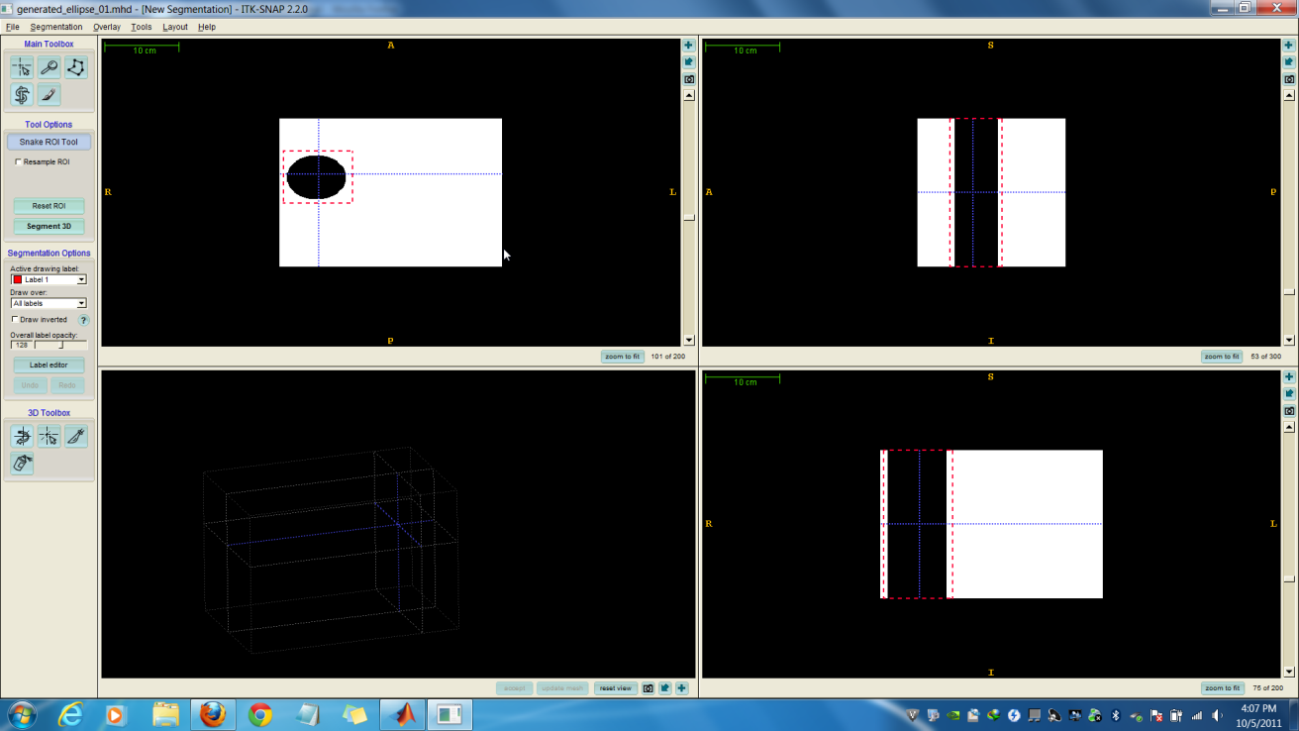

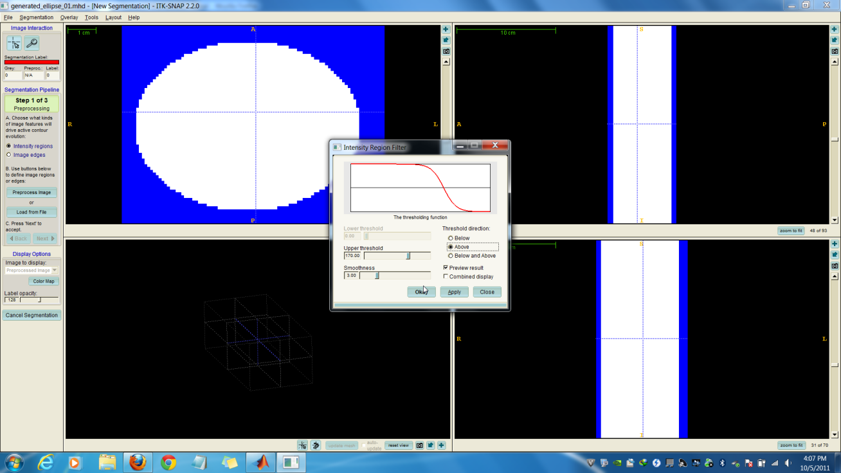

Step 3: Choose the seed bubble such that a part of it is inside the ellipse and a part of it is outside the ellipse.

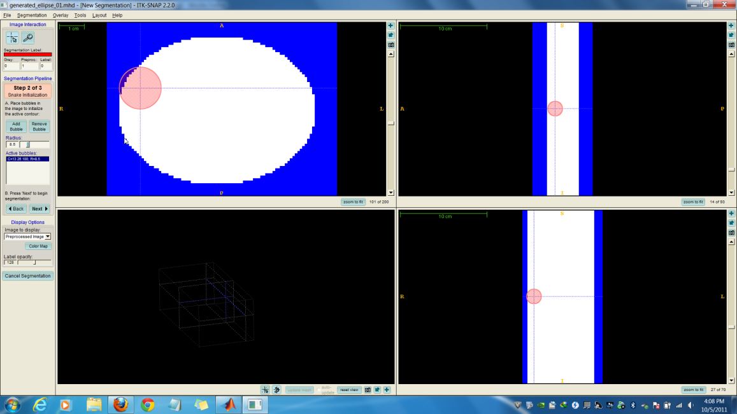

Step 4: Configure the parameters for the Geodesic Snakes Segmentation and run the program. Once the segmentation is finished, save the segmentation image.

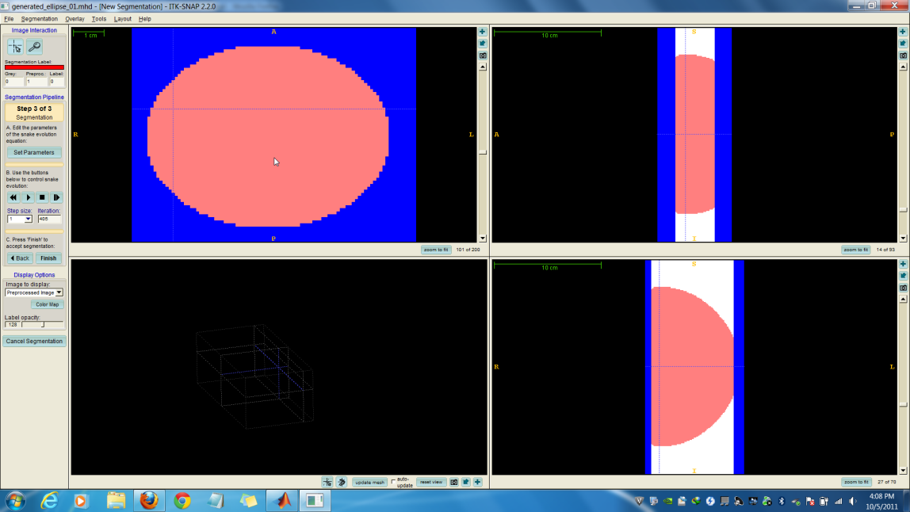

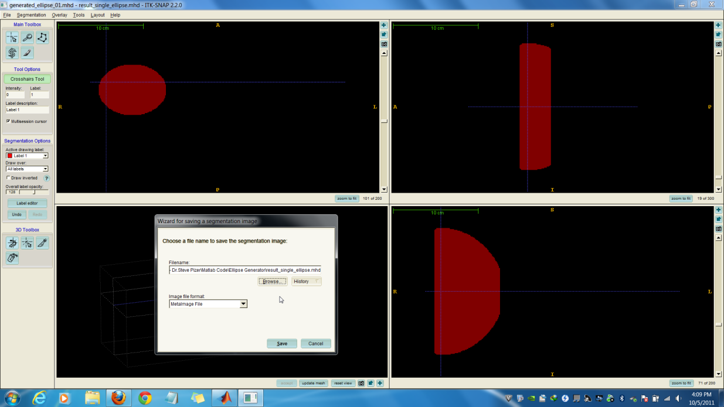

Step 4: Read the saved segmentation image via below Matlab code and save a single slice of the same and open it in ITKSnap to see the result.

Code

segmented_image = loadMETA('segmented_ellipse.mhd');

single_ellipse = segmented_image(:,:,101);

writeMETA(single_ellipse, 'result_single_ellipse.mhd');

